SPRINT-4

|  |  |
| --- | --- |
| Date | 10 November 2022 |
| TEAM ID | PNT2022TMID12310 |
| Project Name | IoT Based smart crop Protection system for agriculture |
| Maximum mark | 20 marks |

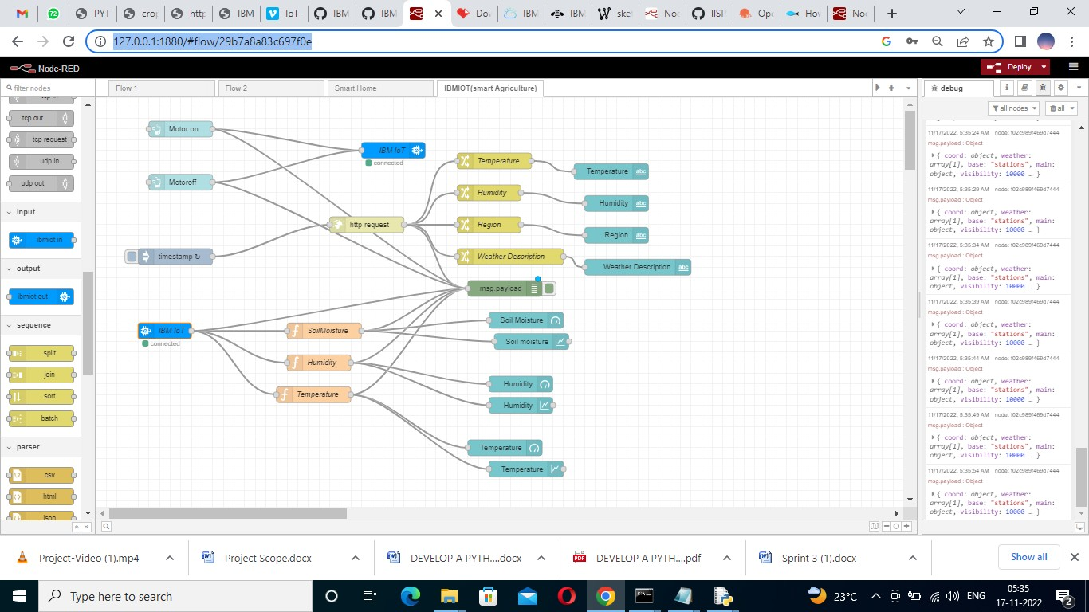

SIMULATION:

Simulated program to get the random values.

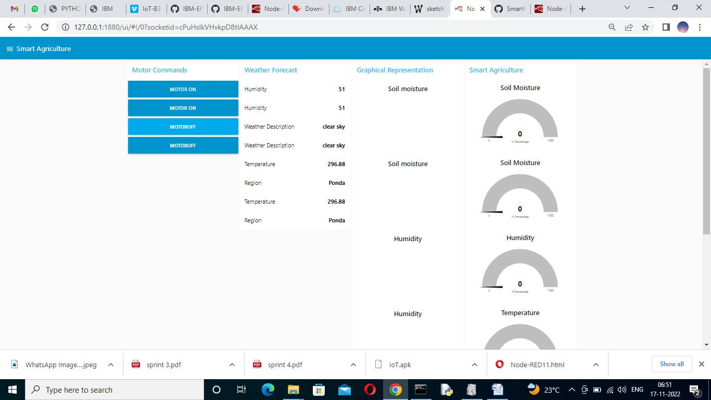

STEP2: Generate debug message from IBM Watson IOT Platform and connect the nodes.

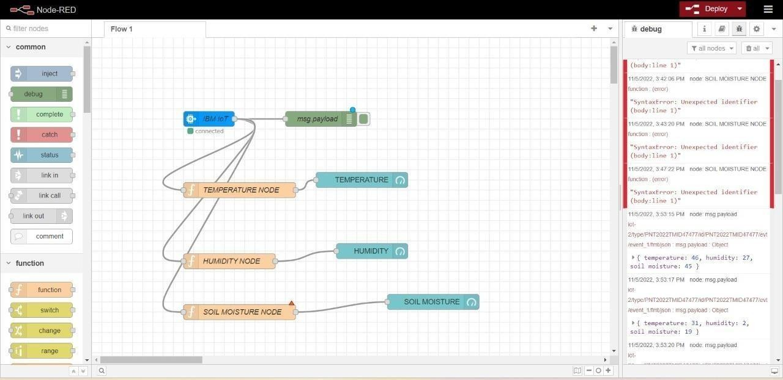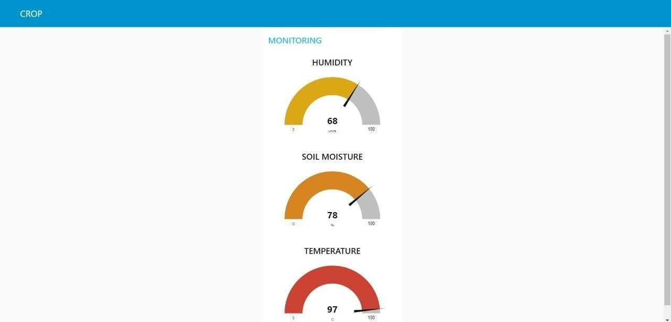

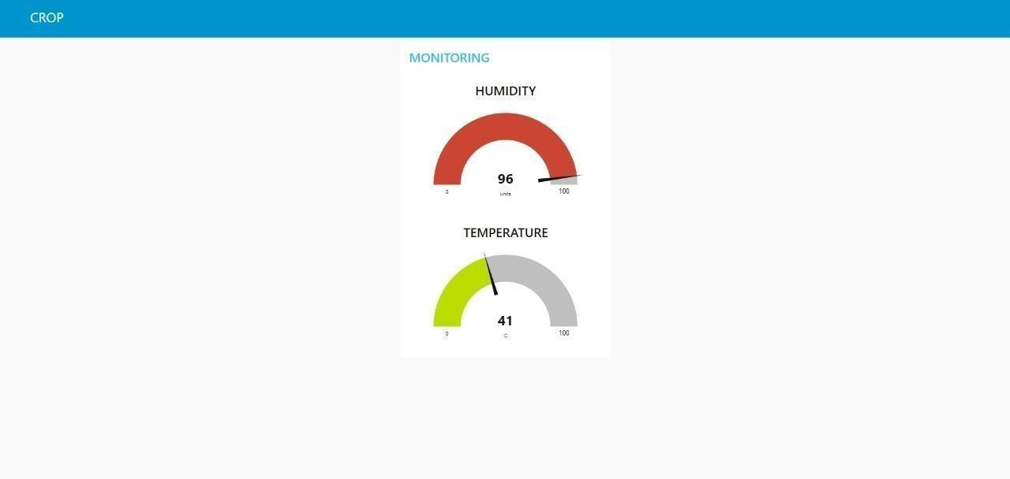

STEP3: Generate the some output from recent events

